Constant pool memory
Primitive data types stored in the constant pool
Primitive data types are
Numbers, strings, booleans

Heap memory
Non-primitive data types stored in the heap memory
Non-primitive data types are
Arrays, object literals, functions

Variable stack
Declared variables stored in the variable stack

Constant pool

When your declaring or creating a value in the memory when your assigning the value into a variable the variable holds the address or reference of that value

If x = 10 means 10 creates a memory in the constant pool and address assigned to the x
If y = 20 means 20 creates a memory location in the constant pool address assigned to the y
But when you write z = 10 so there is no memory creates in the constant already 10 is there in memory so the same reference is shared to the z also.

If we write name = Raj it will create a memory and share the location address to name
Again if we write var = Raj the same memory address shared to the var also

So Raj memory exist at name and var
So if i try to modify the var[0] = “C” if the character changes the same Raj is answerable for name also thats why it is immutable we can replace the value but we can not edit the value.
If we write name = “Chary”
So Chary memory creates in constant and assigned to the name like we can replace a string to name variable

Garbage collection
The one clearing the unused values in memory is garbage collector
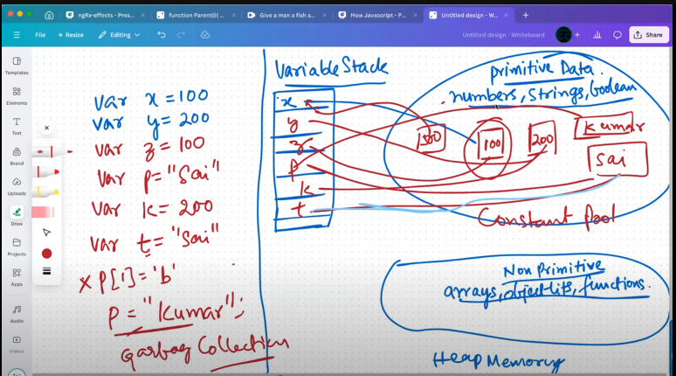

Heap memory

The same flow apply for non primitive but the memory creation is different for different declaration
So if create x = [10,20] the memory created for [10,20] and assigned to the x
Again iam create y = [10,20] again the memory created for [10,20] and assigned to the y
But not assigned previous x value to the y
X is having diff location
Y is having diff location
If i write x = z the same location reference is assigned to the z then x and z are equal

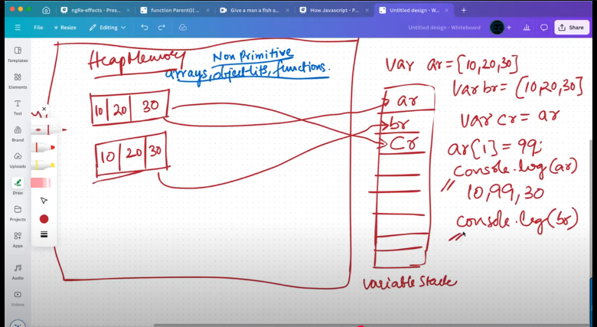
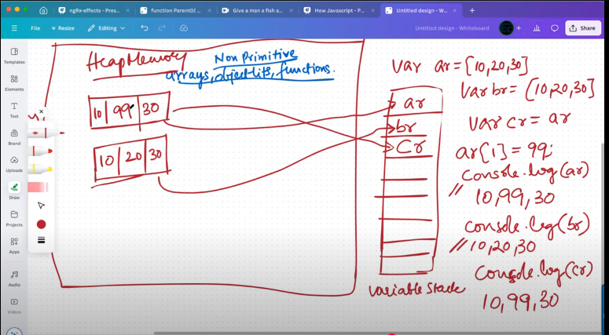

Reference types are
Arrays, object literals, functions
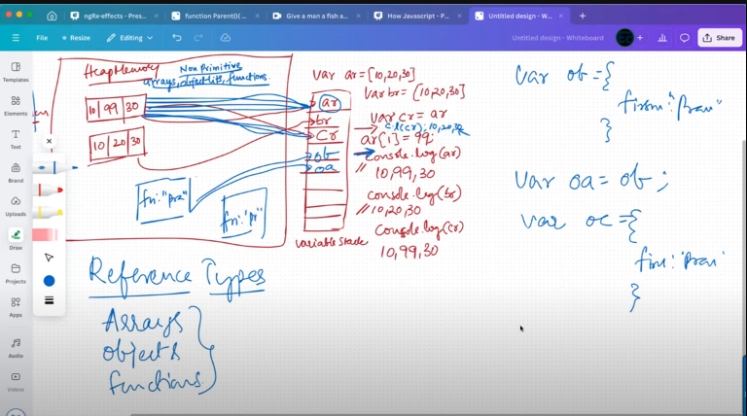

Referential equality
